**E-Stock Market Implementation**

GitHub Repository Path:

<https://github.com/prosenjit005/E-Stock-Market-Project>

# Implementation Flow

Login Page: user1/password1

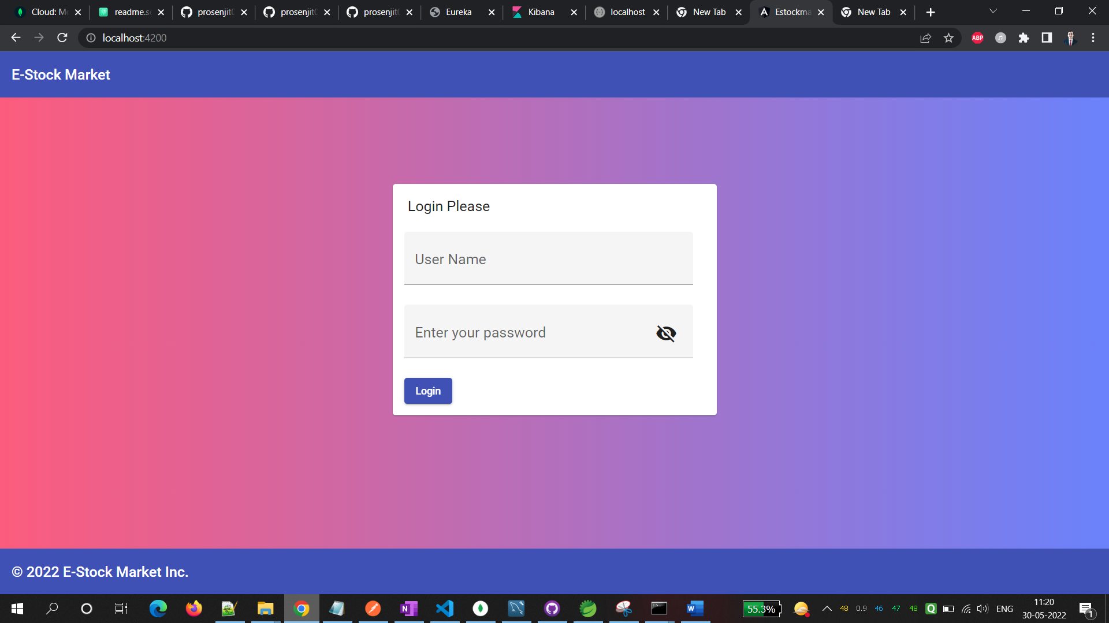

Landing Page after login:

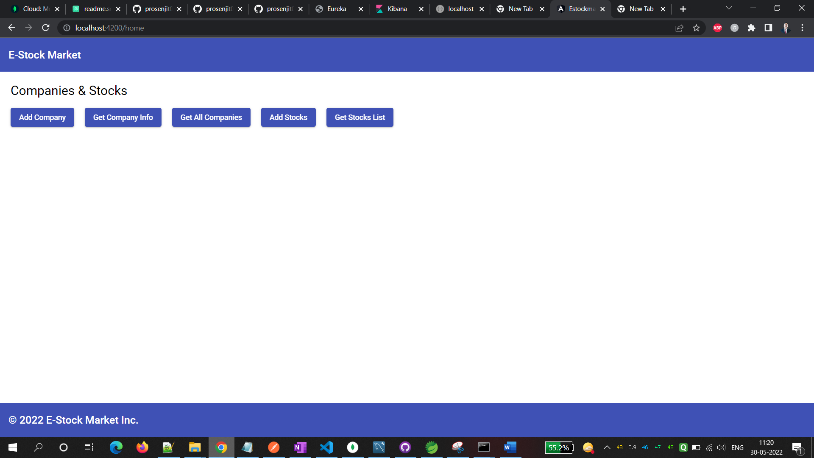

Add Company:

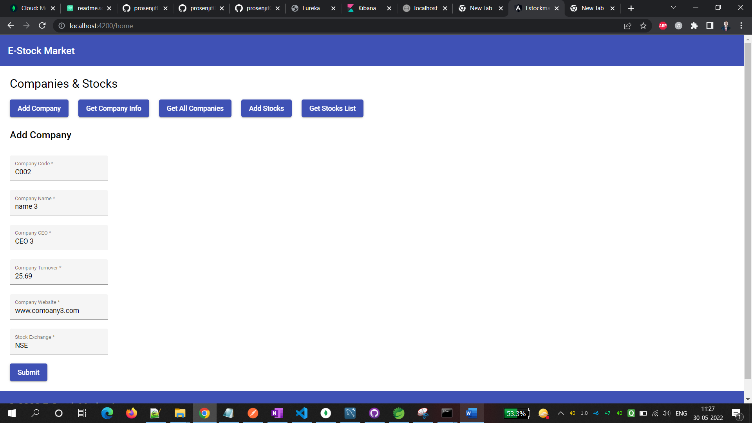

Get Company Info:

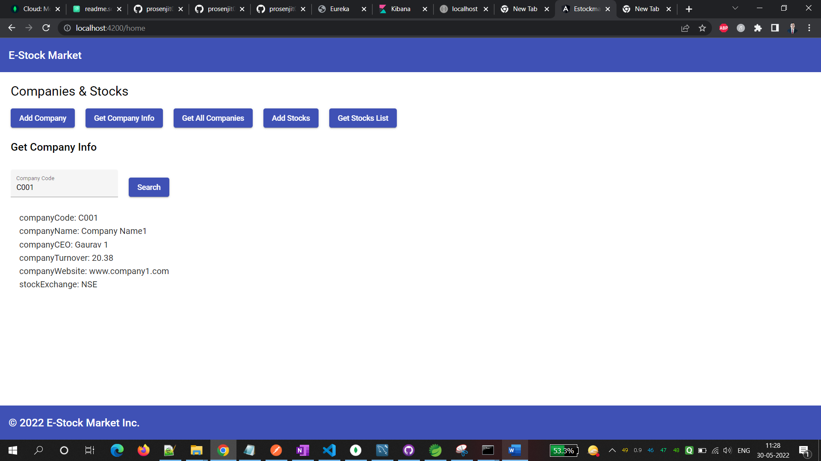

Get All Companies:

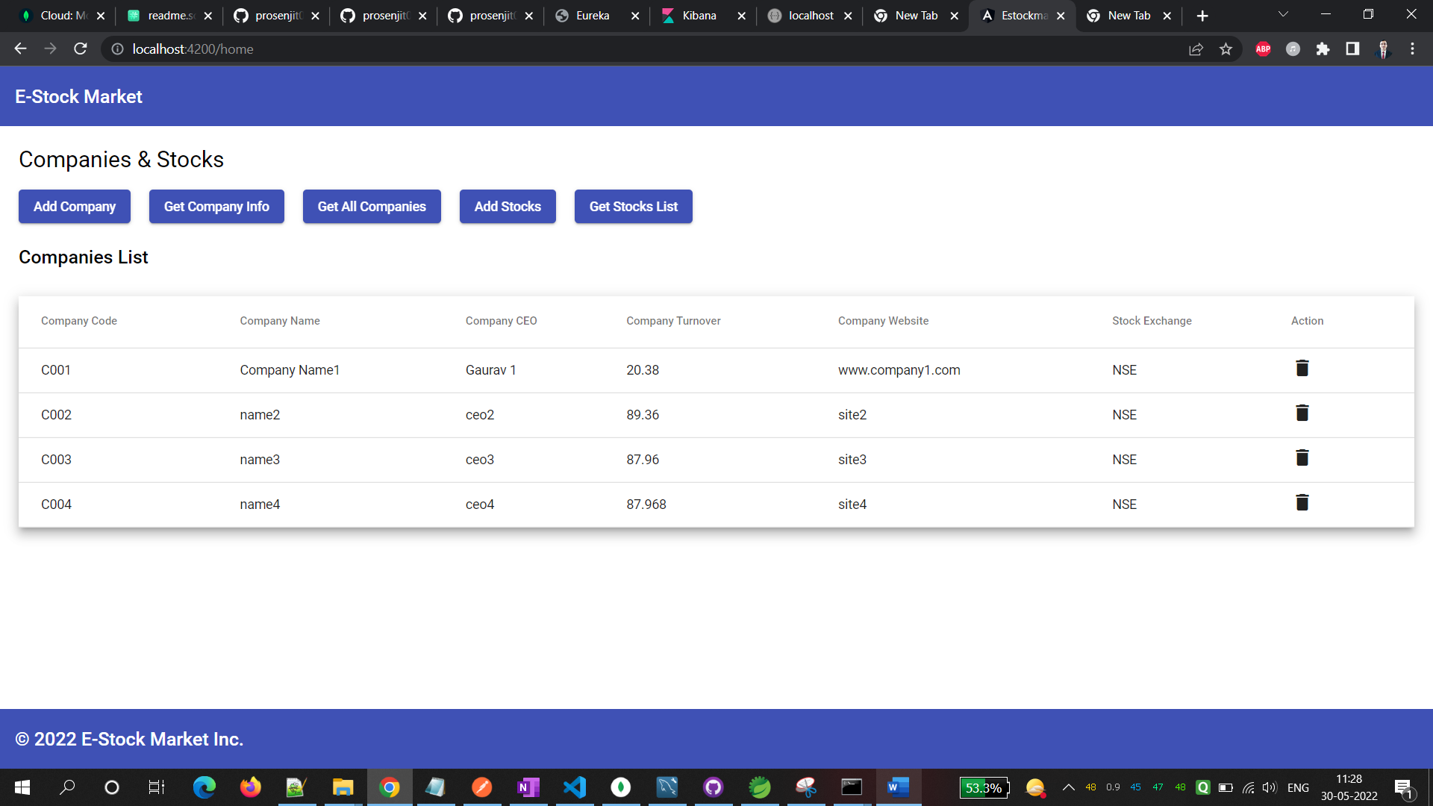

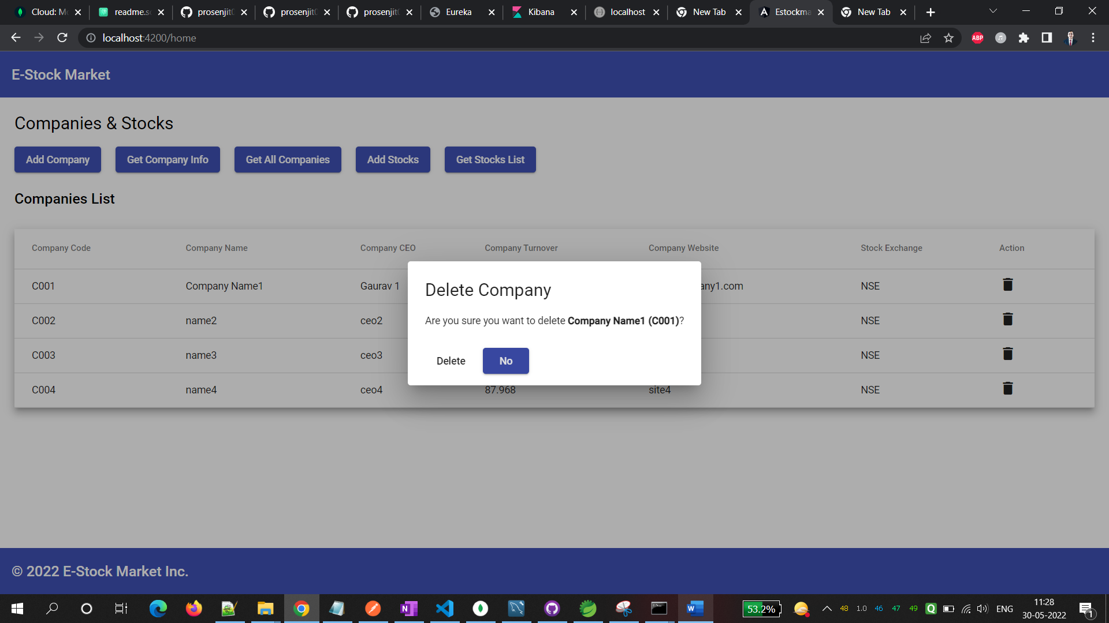

Add Stocks:

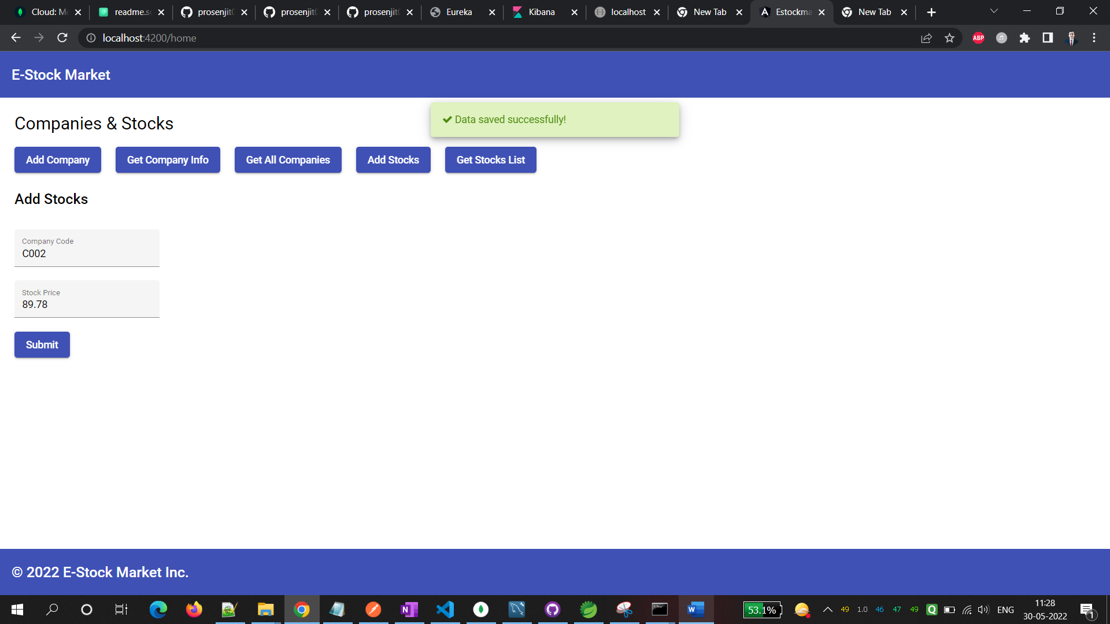

Get Stocks List:

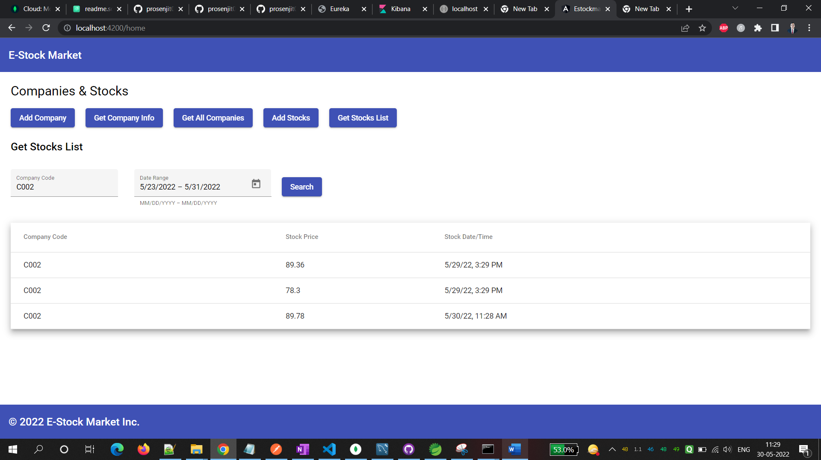

Done! All working as expected.